ANTIULCER AND TOXICOLOGICAL EVALUATION OF BI-HERBAL MIXTURE OF EMILIA COCCINEA AND OCCIMUM GRATISSIMUM ON WISTAR RATS
Gabriel Ogunma Benjamin¹, Adedokun Oluwasegun Adekanmi² and Ume Ogochukwu³
¹ Phytomedicine Unit, Department of Botany, University of Benin, Nigeria
² Department of Pharmacognosy, Igbinedion University, Nigeria
³ Department of Pharmaceutical Chemistry, Igbinedion University, Nigeria
Email: adedokun.oluwasegun@iuokada.edu.ng +2348035485083
alexthemain076@gmail.com +2347032695752
Abstract
Emilia coccinea and Ocimum gratisimum are employed in folk medicine in the management of gastro-intestinal tract disorders such as peptic ulcers. The bi-herbal methanol extracts of E. coccinea and O. gratisimum was evaluated for its anti-ulcerogenic effect and toxicity profile in rats. Graded doses of bi-herbal extracts (25, 50 and 100 mg/kg) were orally administered to the treated groups. Cimetidine at doses 100 mg/kg were used as positive controls, respectively. Stomach was opened along the greater curvature then ulceration index was determined examining the inner lining of stomach. Oral administration of the extract did not produce toxic effects to the haematological parameters and selected tissues in rats. The bi-herbal extracts (25, 50 and 100 mg/kg) showed a significant reduction in ulcer index and percentage in HCl/Ethanol-induced ulcer. Bi-herbal extracts (25, 50 and 100 mg/kg) showed antiulcer activity against ethanol-induced gastric lesions dose dependently. The extract efficiently inhibited thedevelopment of gastric lesions induced by ethanol. The results indicated that bi-herbal extract exerted an anti-ulcergenic effect associated with an increase in gastric mucosal defensive factors.
Keywords: ulcer, Bi-herbal, Cimetidine, Toxicology, Emilia coccinea, Occimumgratissimum
Abstrato
Emilia coccinea e Ocimum gratisimum são empregados na medicina popular no tratamento de distúrbios do trato gastrointestinal, como úlceras pépticas. Os extratos extra-herbáceos de metanol de E. coccinea e O. gratisimum foram avaliados quanto ao efeito anti-ulcerogênico e perfil de toxicidade em ratos. Doses graduais de extra-bi-herbal (25, 50 e 100 mg / kg) foram administradas por via oral ao grupo tratado. A cimetidina nas doses de 100 mg / kg foi utilizada como controlos positivos, respectivamente. Estômago foi aberto ao longo da curvatura maior, em seguida, o índice de ulceração foi determinado examinando o revestimento interno do estômago. A administração oral do extrato não produziu efeitos tóxicos nos parâmetros hematológicos e tecidos selecionados em ratos. Os extratos extra-herbáceos (25, 50 e 100 mg / kg) mostraram uma redução significativa no índice de úlcera e percentual de úlcera induzida por HCl / Etanol. Ervas extra-herbáceas (25, 50 e 100 mg / kg) apresentaram atividade antiúlcera contra dose dose gástrica induzida pelo etanol de forma dependente. O extrato inibe eficientemente o desenvolvimento de lesões gástricas induzidas pelo etanol. Os resultados indicaram que o bi-extrato foi exercido com um efeito anti-ulcerogênico associado a um aumento nos fatores defensivos da mucosa gástrica.
INTRODUCTION
Several plant materials with medicinal benefits are being employed in the management of diverse disease [1]. Phytochemicals are the constituentliable for most plants efficacy. Emilia coccinea known as scarlet tassel flower, belong to the family Compositae. In herbal medicine, the leaves and the root are employed in the management of several diseases[2]. Ethnomedicinal report exhibited E. coccinea leaf being used to manage sores, treat vertigo [3, 4]. More so, it is proven effective in treating ringworm, gonorrhea, ulcer, measles and convulsion in children [2, 5]. Some of the bioactivities in this plant have been reportedsuch as, anti-diarrhoeal, anti-microbial and anti-fungal activity [6 - 8]. Ocimum gratissimumare differently known in their local names. It is called scent leaf in English, Nchuanwu by the Igbos, Effrin-nla by the Yorubas and Daidoya by the Hausas [2, 9].In the southern part of Nigeria, crude aqueous extract of O. gratissimum is commonly used in the treatment of high fever, epilepsy, diarrhea[10]. In Kenya, it is an important herbal medicine; the leaves are rubbed between the palms and sniffed as a treatment for blocked nostrils [11]. They are also used for abdominal pains, sore eyes, and ear infections, for coughs, fever, convulsions, tooth gargle, regulation of menstruation and as a cure for prolapsed of the rectum [12]. In India, the whole plant has been used for the treatment of sunstroke, headache, and influenza, as a diaphoretic, antipyretic and for its anti-inflammatory activity [13].
Traditionally, peptic ulcers have been described as an imbalance between the luminal acid peptic attacks versus the mucosal defenses. Acid and pepsin components form the aggressive factors, and the mucus layer of mucin-bicarbonate secretion, phospholipid layer, tight junctions’ cell proliferations, prostaglandins, and the urogastrone epidermal healing factors form the defensive factors [14]. Enhancement of gastric mucus has been proposed to explain antiulcer activity [15].

INTRODUÇÃO
Muitos materiais vegetais com benefícios medicinais estão sendo empregados no manejo de várias doenças [1]. Os fitoquímicos são os constituintes responsáveis ​​pela maior parte da eficácia das plantas. Emilia coccinea conhecida como flor borla escarlate, pertence à família Compositae. Na fitoterapia, as folhas e a raiz são empregadas no manejo de muitas doenças [2]. O relatório etnomedicinal mostra que a folha de E. coccinea está sendo usada para controlar feridas, tratar a vertigem [3, 4]. Mais ainda, é comprovadamente eficaz no tratamento de micose, gonorréia, úlcera, sarampo e convulsão em crianças [2, 5]. Algumas das bioactividades nesta planta foram relatadas, tais como, anti-diarrhoal, antimicrobiana e atividade anti-fúngica [6 - 8]. Ocimum gratissimum são diferentemente conhecidos em seus nomes locais. É chamado folha do perfume em inglês, Nchuanwu por Igbos, Effrin-nla pelos Yorubas e Daidoya pelos Hausas [2, 9]. Na parte do sul da Nigéria, bruto bruto aquoso de O. scissimum é comumente usado no tratamento de febre alta, epilepsia, diarréia [10]. No Quênia, é um importante remédio herbal; as folhas são esfregadas entre as palmas das mãos e cheiradas como tratamento para narinas bloqueadas [11]. Eles também são usados ​​para dores abdominais, dor nos olhos e infecções de ouvido, para a tosse, febre, convulsões, gargarejo dente, o Regulamento da menstruação e como uma cura para prolapso do reto [12]. Na índia, toda a planta tem sido usada para o tratamento de insolação, mensagens de texto, e da gripe, como um sudorífico, antipirético e pela sua actividade anti-inflamatória [13].Tradicionalmente, as úlceras pépticas têm sido descritas como um desequilíbrio entre os ataques pépticos do ácido luminal versus as defesas da mucosa. Ácido e pepsina Componentes formar os factores agressivos, e a camada de muco da secreção de mucina-bicarbonato, a camada de fosfolípido, proliferações celulares junções apertadas, as prostaglandinas, e a epidérmico urogastrona factores de cura formar os factores defensivos [14]. O aumento do muco gástrico tem sido proposto para explicar a atividade antiulcerosa [15].

MATERIAL AND METHODS
Plant collections
The two plants were collected freshly from plant biology and biotechnology garden University of Benin, Edo state. It was identified and authenticated by Dr. AkiniBosun of the Department of Plant Biology and Biotechnology, University of Benin.
Plant Preparation
The freshly collected leaves from the two plants were rinsed and air dried until properly dried, the dried samples werepulverized using British grinder. Equal weights of the two powered sampleswere taken and dissolved into methanol for 72hours using 1:1. The filtrate was concentrated and stored for further use.
Experimental Animals
The study was carried out using male albino rats, weighing 180–200g. The rats were obtained from animal house of Biochemistry Department, University of Benin University, Benin City. The animals were housed under 12 h light-dark cycle and received pelleted food and water ad libitum. They were allowed to acclimatize to laboratory conditions for 2 weeks. The animals were handled according to standard protocols for the use of Laboratory animals.
Hydrochloric acid/Ethanol-induced ulcer
Albino rats were divided into five (5) groups as reported by [16] and fasted for 18 hours prior to oral dosing with the distilled water (0.5 ml/kg), Cimetidine (100 mg/kg). Bi-herbal methanol extracts (25, 50 and 100 mg/kg). One hour following treatments, the whole animals were exposed to 0.5 ml of a 0.3M HCl/60% Ethanol solution orally. Animals were euthanized by cervical dislocation 1 h after administration of HCl/Ethanol solution; the stomachs were isolated and exposed along the greater curvature. Gastric contents and blood clots were removed then the stomachs were interpreted and rinsed in formaldehyde for histological study. The gastric mucosa walls were observed for lesions using binocular stereomicroscope (Nikon SMZ-10).
Ulcer index was estimatedusing the method of [17]. The number and severity of lesions were evaluated. The following scores were used: light (I), presence of edema, hyperemia and single petechiae; moderate (II), presence of sub-mucosal hemorrhagic lesions with small erosions; severe (III), presence of hemorrhagic lesions with severe erosions.

Ulcer Index (UI) = (nI) + (nII) 2 + (nIII) 3\Number of animals

Where: n is the number of lesions.
The preventive effect was calculated by the method of [18] as follow:
Prevention index (%) = UI Control – UI Treated\UI Control × 100
UI Control = ulcer index in the negative control group
UI Treated = ulcer index in the group receiving HEGG
Ethanol-induced ulcer
The test was implemented by slight modification of method described by [19]. Animals werefasted for 18 hours prior to oral dosing with the distilled water (0.5 ml/kg), Cimetidine (100 mg/kg). Bi-herbal methanolextracts (25, 50 and 100 mg/kg). 60 minutes after treatments, the whole animals were exposed to 1 ml 75% Ethanol solution orally. Animals were euthanized by cervical dislocation 60 minutes after administration of Ethanol solution; the stomachs were isolated and exposed along the greater curvature.And the procedure of calculation was adopted from the above method
Toxicological evaluation
Hematology Assays
3 ml of blood were collected across the groups at day 14 into a 5 ml EDTA tubes by abdominal aortal using syringes and needles. The haematological analysis was done almost immediately using an automatic haemato-analyser (Sysmex, KX-21, Japan).
Histological study
The organs (Liver, Kidney) were fixed in 10 % (vol/ vol) formaldehyde, cleaned up in xylene and embedded in a paraffin wax (melting point at 56 percent). Tissue sections were prepared according to the method of (Drury and Wallinton, 2013)and stained with eosin/ hematoxylin. Photomicrographs were taken at ×400 using a digital camera.
Statistical analysis
Data were presented as Mean ± SEM of the respective replicates. Means of different groups were compared using ANOVA using graph pad prism 6 version computer software packages.
MATERIAL E MÉTODOS
Coleções de plantas
As duas plantas foram coletadas recentemente de biologia vegetal e jardim de biotecnologia da Universidade de Benin, estado de Edo. Foi identificado e autenticado pelo Dr. Akini Bosun do Departamento de Biologia Vegetal e Biotecnologia da Universidade de Benin.
Preparação de Planta
As folhas recém colhidas das duas plantas foram enxaguadas e secas ao ar até estarem devidamente secas, as amostras secas foram pulverizadas usando um moinho britânico. Pesos iguais das duas amostras energizadas foram retirados e dissolvidos em metanol por 72 horas usando 1: 1. O filtrado foi concentrado e armazenado para uso posterior.
Animais Experimentais
O estudo foi realizado utilizando ratos albinos machos, pesando 180-200 g. Os ratos foram obtidos a partir da casa de animais do Departamento de Bioquímica da Universidade da Universidade de Benin, Benin City. Os animais foram alojados sob um ciclo claro-escuro de 12 h e receberam ração peletizada e água ad libitum. Eles foram autorizados a aclimatar a condições de laboratório por 2 semanas. Os animais foram tratados de acordo com os protocolos padrão para o uso de animais de laboratório.
Ácido clorídrico / úlcera induzida por etanol
Ratos albinos foram divididos em cinco (5) grupos conforme relatado por [16] e em jejum por 18 horas antes da dosagem oral com água destilada (0,5 ml / kg), Cimetidina (100 mg / kg). Extratos bimetálicos de metanol (25, 50 e 100 mg / kg). Uma hora após os tratamentos, os animais inteiros foram expostos a 0,5 ml de uma solução de 0,3MHC1 / 60% de etanol por via oral. Os animais foram eutanasiados por deslocamento cervical 1 h após a administração da solução de HCl / Etanol; os estômagos foram isolados e expostos ao longo da curvatura maior. O conteúdo gástrico e os coágulos sanguíneos foram removidos e os estômagos foram interpretados e lavados em formaldeído para estudo histológico. As paredes da mucosa gástrica foram observadas para lesões usando estereomicroscópio binocular (Nikon SMZ-10).
O índice de úlcera foi estimado pelo método de [17]. O número e a gravidade das lesões foram avaliados. Os seguintes escores foram utilizados: luz (I), presença de edema, hiperemia e petéquias únicas; moderada (II), presença de lesões hemorrágicas submucosas com pequenas erosões; grave (III), presença de lesões hemorrágicas com er
osões severas.
Índice de Úlcera (UI) = (nI) + (nII) 2 + (nIII) ​​3 \ Número de animais
Onde: n é o número de lesões.
O efeito preventivo foi calculado pelo método de [18] como segue:
Índice de Prevenção (%) = Controle da IU - Controle da UI \ UI × 100
UI Control = índice de úlcera no grupo controle negativo
UI Tratado = índice de úlcera no grupo que recebeu HEGG
Úlcera induzida por etanol
O teste foi implementado por uma ligeira modificação do método descrito por [19]. Os animais foram submetidos a jejum durante 18 horas antes da dosagem oral com a ua destilada (0,5 ml / kg), Cimetidina (100 mg / kg). Extratos bimetálicos de metanol (25, 50 e 100 mg / kg). 60 minutos após os tratamentos, os animais inteiros foram expostos a 1 ml de solução de etanol a 75% por via oral. Os animais foram eutanasiados por deslocamento cervical 60 minutos após a administração da solução de etanol; os estômagos foram isolados e expostos ao longo da curvatura maior. E o procedimento de cálculo foi adotado a partir do método acima
Avaliação toxicológica
Ensaios de hematologia
Recolheram-se 3 ml de sangue ao longo dos grupos no dia 14 para tubos de EDTA de 5 ml através de aorta abdominal utilizando seringas e agulhas. A análise hematológica foi feita quase imediatamente usando um hemato-analisador automático (Sysmex, KX-21, Japão).
Estudo histológico
Os órgãos (Fígado, Rim) foram fixados em formaldeído a 10% (vol / vol), limpos em xileno e embebidos em cera de parafina (ponto de fusão a 56 por cento). As secções teciduais foram preparadas de acordo com o método de (Drury e Wallinton, 2013) e coradas com eosina / hematoxilina. As fotomicrografias foram tiradas em × 400 usando uma câmera digital.
Análise estatística
Os dados foram apresentados como Média ± EPM das respectivas repetições. Meios de diferentes grupos foram comparados usando ANOVA usando prisma de blocos de grafos 6 pacotes de software de computador vErsão.

RESULTS
Phytochemical screening
Table 1 shows the present of certain plant chemicals that enhances biological activities and display healing property on disease conditions.
Table 1: Phytochemical constituent of bi-herbal methanol extract
Tests | Methanolbi-herbal extract
Alkaloids | +++
Tannins | ++
Saponins | +++
Flavonoids | ++
Phenolics | ++
Keys: presence of the constituent = +
Anti-ulcer study
Table 2 showed significance increase in the treated groups. The reference drug (100 mg/kg Ranitidine) has an ulcer inhibition of 99 % compared with the 0.0% ulcer inhibition of the negative control group. 100 mg/kg plant extract of the treated group inhibits ulcer more at 100 % likewise 25 and 50 mg/kg compared with the negative control.

Table 2: Effect of bi-herbal methanol crude extracts on ulcer Index and percentage inhibition of ulcer index (IU) % using HCL/ethanol induced ulcer model
Parameters/ Group | Dosages (mg/kg) | Ulcer Index (IU) | Percentage inhibition of Ulcer Index (IU) %
Distilled Water | 0.5 ml | 41.93±11.35 | -
Cimetidine | 100 | 0.42±0.23^{b} | 99.00
Methanol Extracts | 25 | 9.33±2.18ª | 77.75
Methanol Extracts | 50 | 6.22±4.35ª | 85.17
Methanol Extracts | 100 | 0.00±0.00^{c} | 100
P- value(superscript ª= 0.05, ^{b}= 0.1, ^{c}=0.01)Mean±SEM, n = 6
A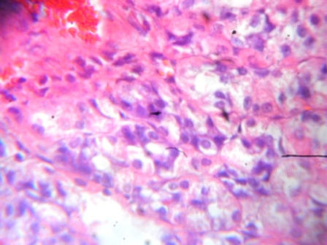 B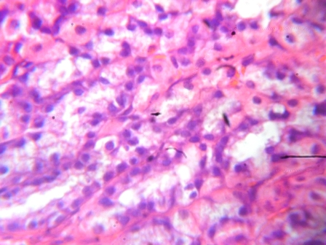C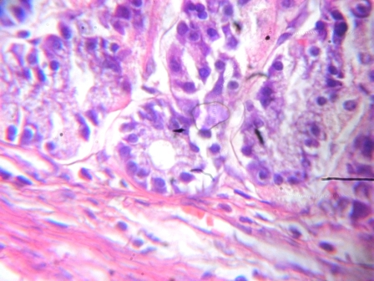
D E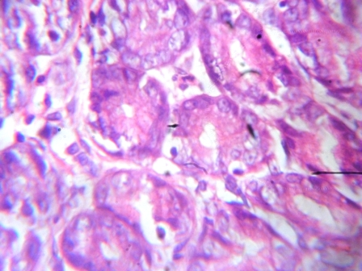F

Plate I: (B). antiulcer activity on the stomach lining gives clearer pictures of the mucosa membrane in positive control by showing a well-defined and healthy stomach. (C, D, E, F) has same observation noted on the normal control and treated groups specifically at 25, 50 and 100 mg/kg compared with the (A) negative control which showed a devitalised stomach thereby indicating the presence of ulcer.

Table 3 showed significance increase in the treated groups. The reference drug(20 mg/kg Ranitidine) has an ulcer inhibition of 98.98% compared withthe 0.0% ulcer inhibition of the negative control group. 100 mg/kg plant extract of the treated group inhibits ulcer more at100 % likewise25and 50mg/kg compared with the negative control.
Table 3: Effect of bi-herbal methanol crude extracts on ulcer Index and percentage inhibition of ulcer index (IU) %usingethanol induced ulcer model
Parameters/ Group | Dosages (mg/kg) | Ulcer Index (IU) | Percentage inhibition of Ulcer Index (IU) %
Distilled Water | 0.5 ml | 32.33±11.35 | -
Cimetidine | 100 | 0.33±0.33^{c} | 98.98
Methanol Extracts | 25 | 11.33±3.18ª | 64.96
Methanol Extracts | 50 | 5.83±5.33^{b} | 81.96
Methanol Extracts | 100 | 0.00±0.00^{c} | 100
P- value (superscript ª= 0.05, ^{b}= 0.1, ^{c}=0.01)Mean±SEM, n=6
A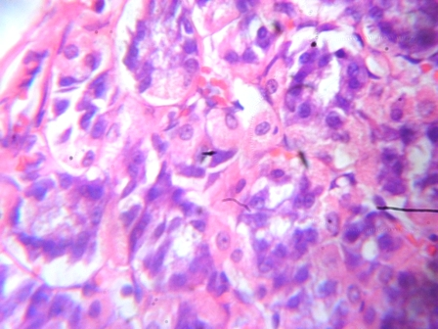 B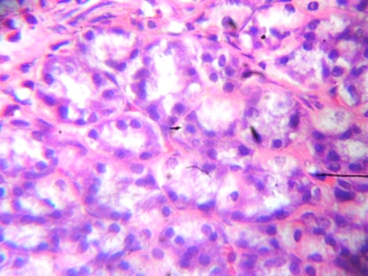C
D EF

Plate 2: B. antiulcer activity on the stomach lining gives clearer pictures of the mucosa membrane in positive control by showing a well-defined and healthy stomach. C, D, E, F.has same observation noted on the normal control and treated groups specifically at 25, 50 and 100 mg/kg compared with the A. negative control which showed a devitalised stomach thereby indicating the presence of ulcer.

Toxicological evaluation
From Table 4, no toxic effect was observed on the haematological parameter, showing that its synergic action post no harm.
Table 4: Effect of bi-herbal (methanol extracts on haematological indices across the groups.
Parameters | Normal Control | 25 mg/kg Methanol | 50 mg/kg Methanol | 100 mg/kg Methanol
BC x 10³ / ul | 17.40±1.89 | 12.77±3.12 | 14.17±0.67 | 14.00±4.92
LY x 10³ / ul | 12.60±1.14 | 6.90±0.47 | 6.93±0.66 | 8.43±2.74
MO x 10³ / ul | 2.07±0.33 | 1.40±0.31 | 1.70±0.00 | 2.03±0.70
GR x 10³ / ul | 2.80±0.53 | 4.57±2.52 | 5.53±1.19 | 4.23±1.13
LY% | 72.13±1.85 | 58.10±8.91 | 49.53±6.58 | 57.23±3.19
MO% | 11.73±0.73 | 11.07±0.58 | 11.80±0.55 | 13.47±0.44
GR% | 16.00±1.56 | 30.83±9.41 | 38.67±7.05 | 29.30±3.21
RBC x 10⁶ / ul | 8.37±0.39 | 10.06±0.32 | 10.31±0.46 | 8.65±0.34
Hgb.g/d l | 13.63±0.52 | 17.50±0.30 | 18.10±1.66 | 14.63±0.64
HCT% | 42.80±1.30 | 50.97±1.25 | 52.70±5.35 | 43.30±1.37
MCV.f l | 51.37±3.81 | 50.80±2.66 | 50.90±3.35 | 50.10±0.95
MCH.pg | 16.23±0.52 | 17.37±0.89 | 17.43±0.98 | 16.87±0.33
MCHC.g/d l | 31.87±1.62( | 34.30±0.40 | 34.37±0.33 | 33.70±0.42
RDW% | 17.10±1.27 | 16.27±0.68 | 17.00±0.60 | 15.80±0.10
PLT x 10³ /ul | 462.0±33.25 | 468.3±18.77 | 476.7±49.71 | 502.3±102.1
PCT.% | 0.28±0.02 | 0.28±0.01 | 0.28±0.03 | 0.36±0.07
MPV.f l | 6.03±0.03 | 5.97±0.13 | 5.93±0.09 | 5.87±0.09
PDW. % | 6.8j7±0.09 | 7.23±0.35 | 7.37±0.49 | 6.67±0.15
P-valuep<0.05, Mean±SEM, n=6

From plate 3; the histological study of the hepatocyte exhibited no tissue damage to the cells, instead the bi-herbal extracts synergise to enhance the effectiveness of the liver cells and blood flow when compared with the control group.

A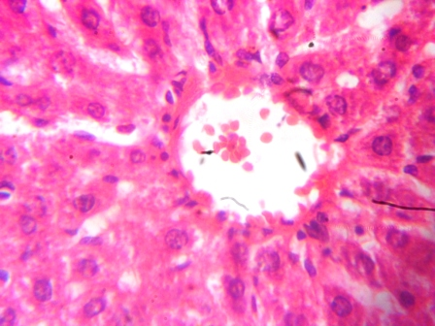 B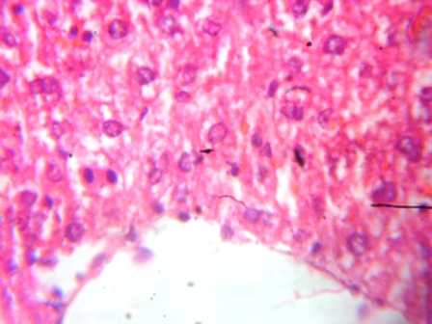
C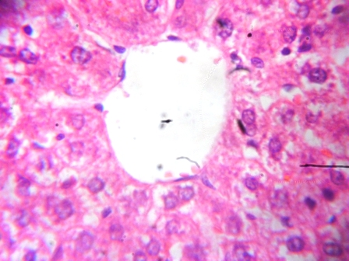 D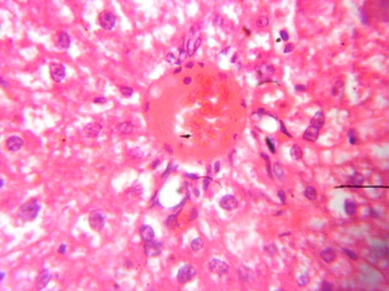

Plate 3: From the histopathological study, the picture of the hepatocytes indicated no diseases condition associated to the control (A). The same observation was noted from the graded doses across the treated groups (B, C, D).
From plate 3; the histological study of the hepatocyte exhibited no tissue damage to the cells, instead the bi-herabal extracts synergise to enhance the effectiveness of the liver cells and blood flow when compared with the control group.

A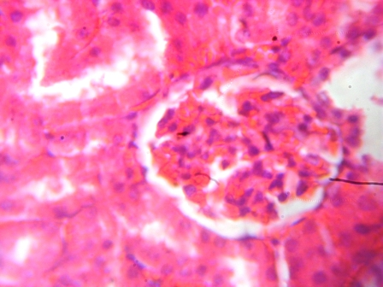 B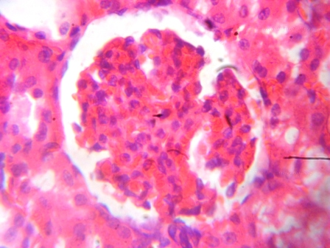
C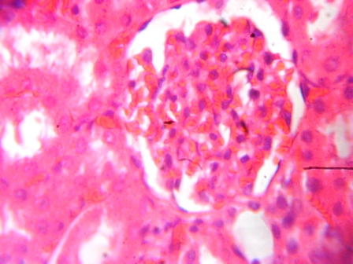 D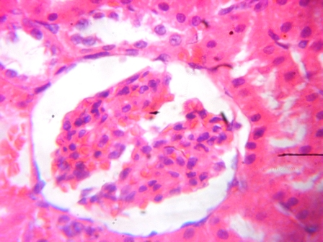

Plate 4: From the histopathological study, the picture of the kidney is an indication of no diseases condition associated to the control (A). The same observation goes to the normal control and graded doses of the treated groups (B, C, D).

RESULTADOS
Rastreio fitoquímico
A Tabela 1 mostra a presença de certas substâncias químicas da planta que melhoram as atividades biológicas e apresentam propriedades curativas nas condições da doença.

Tabela 1: Constituinte fitoquímico do extrato bimetálico de metanol

Tests | Methanol bi-herbal extract
Alkaloids | +++
Tannins | ++
Saponins | +++
Flavonoids | ++
Phenols | ++
Chaves: presença do constituinte = +

Estudo anti-úlcera
A Tabela 2 mostrou aumento de significância nos grupos tratados. A droga de referência (100 mg / kg Ranitidina) tem uma inibição da úlcera de 99% em comparação com a inibição da úlcera de 0,0% do grupo controle negativo. 100 mg / kg de extrato vegetal do grupo tratado inibe a úlcera mais em 100% da mesma forma 25 e 50 mg / kg em comparação com o controle negativo.

Tabela 2: Efeito de extractos brutos de bi-plantas de metanol na úlcera Índice e percentagem de inibição do índice de úlcera (UI)% usando modelo de úlcera induzida por HCL / etanol

Parameters/ Group | Dosages (mg/kg) | Ulcer Index (IU) | Percentage inhibition of Ulcer Index (IU) %
Distilled Water | 0.5 ml | 41.93±11.35 | -
Cimetidine | 100 | 0.42±0.23^{b} | 99.00
Methanol Extracts | 25 | 9.33±2.18ª | 77.75
Methanol Extracts | 50 | 6.22±4.35ª | 85.17
Methanol Extracts | 100 | 0.00±0.00^{c} | 100
Valor P (sobrescrito a = 0,05, b = 0,1, c = 0,01) Média ± SEM, n = 6

A BC
D EF

Placa 1: (B) A atividade antiulcerosa no revestimento do estômago produz imagens mais nítidas da membrana mucosa no controle positivo, mostrando um estômago bem definido e saudável. (C, D, E, F) observa a mesma observação nos grupos controle normal e tratado especificamente em 25, 50 e 100 mg / kg em comparação com o controle negativo (A) que mostrou um estômago desvitalizado, indicando a presença de úlcera.

A tabela 3 mostrou aumento de significância nos grupos tratados. O medicamento de referência (20 mg / kg Ranitidina) tem uma inibição da úlcera de 98,98% em comparação com a inibição de 0,0% de úlcera do grupo controle negativo. 100 mg / kg de extrato vegetal do grupo tratado inibe a úlcera mais em 100% da mesma forma 25 e 50 mg / kg em comparação com o controle negativo.
Tabela 3: Efeito dos extractos brutos de bi-plantas de metanol na úlcera Índice e percentagem de inibição do índice de úlcera (UI)% utilizando o modelo de úlcera induzida por etanol

Parameters/ Group | Dosages (mg/kg) | Ulcer Index (IU) | Percentage inhibition of Ulcer Index (IU) %
Distilled Water | 0.5 ml | 32.33±11.35 | -
Cimetidine | 100 | 0.33±0.33^{c} | 98.98
Methanol Extracts | 25 | 11.33±3.18ª | 64.96
Methanol Extracts | 50 | 5.83±5.33^{b} | 81.96
Methanol Extracts | 100 | 0.00±0.00^{c} | 100
Valor P (sobrescrito a = 0,05, b = 0,1, c = 0,01) Média ± SEM, n = 6
A BC
D EF

Placa 2: B. A atividade antiulcerosa no revestimento do estômago fornece imagens mais nítidas da membrana da mucosa no controle positivo, mostrando um estômago bem definido e saudável. C, D, E, F. tem a mesma observação notada nos grupos controlo normal e tratado especificamente a 25, 50 e 100 mg / kg em comparação com o controlo A. negativo que mostrou um estômago desvitalizado indicando desse modo a presença de úlcera.

Avaliação toxicológica
Na Tabela 4, nenhum efeito tóxico foi observado no parâmetro hematológico, mostrando que sua ação sinérgica não causou danos.
Tabela 4: Efeito de bi-ervas (extratos de metanol em índices hematológicos entre os grupos.
Valor de p <0,05, média ± EPM, n = 6

Da placa 3; o estudo histológico do hepatócito não exibiu nenhum dano tecidual às células, em vez disso, os extratos bi-herbicidas sinergizam para aumentar a eficácia das células do fígado e o fluxo sangüíneo quando comparados com o grupo controle.

Parameters | Normal Control | 25 mg/kg Methanol | 50 mg/kg Methanol | 100 mg/kg Methanol
BC x 10³ / ul | 17.40±1.89 | 12.77±3.12 | 14.17±0.67 | 14.00±4.92
LY x 10³ / ul | 12.60±1.14 | 6.90±0.47 | 6.93±0.66 | 8.43±2.74
MO x 10³ / ul | 2.07±0.33 | 1.40±0.31 | 1.70±0.00 | 2.03±0.70
GR x 10³ / ul | 2.80±0.53 | 4.57±2.52 | 5.53±1.19 | 4.23±1.13
LY% | 72.13±1.85 | 58.10±8.91 | 49.53±6.58 | 57.23±3.19
MO% | 11.73±0.73 | 11.07±0.58 | 11.80±0.55 | 13.47±0.44
GR% | 16.00±1.56 | 30.83±9.41 | 38.67±7.05 | 29.30±3.21
RBC x 10⁶ / ul | 8.37±0.39 | 10.06±0.32 | 10.31±0.46 | 8.65±0.34
Hgb.g/d l | 13.63±0.52 | 17.50±0.30 | 18.10±1.66 | 14.63±0.64
HCT% | 42.80±1.30 | 50.97±1.25 | 52.70±5.35 | 43.30±1.37
MCV.f l | 51.37±3.81 | 50.80±2.66 | 50.90±3.35 | 50.10±0.95
MCH.pg | 16.23±0.52 | 17.37±0.89 | 17.43±0.98 | 16.87±0.33
MCHC.g/d l | 31.87±1.62( | 34.30±0.40 | 34.37±0.33 | 33.70±0.42
RDW% | 17.10±1.27 | 16.27±0.68 | 17.00±0.60 | 15.80±0.10
PLT x 10³ /ul | 462.0±33.25 | 468.3±18.77 | 476.7±49.71 | 502.3±102.1
PCT.% | 0.28±0.02 | 0.28±0.01 | 0.28±0.03 | 0.36±0.07
MPV.f l | 6.03±0.03 | 5.97±0.13 | 5.93±0.09 | 5.87±0.09
PDW. % | 6.8j7±0.09 | 7.23±0.35 | 7.37±0.49 | 6.67±0.15

A B
C D

Placa 3: A partir do estudo histopatológico, o quadro dos hepatócitos não indicou condição de doença associada ao controle (A). A mesma observação foi notada a partir das doses graduadas nos grupos tratados (B, C, D).
Da placa 3; o estudo histológico do hepatócito não exibiu nenhum dano tecidual às células, ao contrário, os extratos bi-herabalos sinergizam para aumentar a eficácia das células do fígado e o fluxo sangüíneo quando comparado com o grup o controle.
A B
C D

Placa 4: A partir do estudo histopatológico, a imagem do rim é uma indicação de ausência de condição de doença associada ao controle (A). A mesma observação vai para o controle normal e doses graduadas dos grupos tratados (B, C, D).
DISCUSSION
Phytochemicals an active medicinal plants ingredient have been implicated in the management of diseases. Table 1 show the present of certain phytochemicals in the bi-herbal methanol leaves extracts. The following phytochemicals are includes; alkaloids, flavonoids, tannins, phenol and saponins were present[20, 21].The antiulcer activity revealed that the ethanol extract of the bi-herbal leaves extracts showed significant reduction in the ulcer index, thus showing possiblyantisecretory mechanism of the extracts. Ulcer index factor was utilized for the evaluation of antiulcer propertysince ulcer development is directly interrelated to certain factors includes gastric volume reduction and reduced liberationof total acid level in an increase pH compared with control group (p <0.05) in HCL/ethanol and ethanol induced gastric ulcer model (Table 2 ). Moreover, the disturbance of defensive factors like mucus secretion, bicarbonate, and mucosal blood flow has been reported to cause ulcers [22]. Oral administration of HCl-ethanol mixture at a dose of 2ml per animal was sufficient to induce ulcer. The bi-herbal extracts at a dose of 25, 50, 100 mg/kg p.o. showed significant reduction in ulcer leision compared with the vehicle control group (Table 2 and 3). The percentage reduction of ulcer lesion was compared with standard drug cimetidine.The methanol extract of the bi-herbal leaves of E. coccinea and O. gratisimumexhibited significant reduction in ulcer score on Hcl/ethanol and ethanol induced stress in rats. The ulcer inhibition was found to be 77.75, 85.17 and 100% and 64.96, 81.96 and 100 % respectively
From Table 2 and 3, hydrochloric acid -ethanol and ethanol induced gastric ulcer damage in rats possibly through leukotrienes production and also involvement of 5-lipooxygenase in the formation of ulcer lesion. Prostaglandins also play a role in ethanol–induced ulcer[22]. Thus the protective effect of the methanol extract of the bi-herbal leaves of E. coccinea and O. gratisimum against the gastric damage might be due to protection against 5-lipooxygenase or leukotriene pathway (Goel and Bhattacharya, 1991).. Thecytoprotective action possibly stimulates the prostaglandin synthesis, which in turn is involved in cytoprotection of the gastric mucosa. It is a significant finding thatmethanol extract of the bi-herbal leaves of E. coccinea and O. gratisimumafforded a distinctively high protection against Hcl/ethanol and ethanol induced ulcer in rats. Preliminary phytochemical investigations showed the presence of alkaloids, flavonoids, tannins, phenol and saponins. Hence, the synergic antiulcer activity of bi-herbal E. coccinea and O. gratisimumin this experimental model may be due to the presents of phenol or flavonoids. The results demonstrated that methanol extract of the bi-herbal leaves of E. coccinea and O. gratisimumproduced anti-ulcerogenic effects possessing aanti-secretory, cytoprotective, and proton pump inhibition mechanism. This interesting observation indicates that extract of bi-herbal leaves of E. coccinea and O. gratisimumcan be a potential source for the treatment of ulcer. However, a detailed study such as isolation of active molecules and characterization is required to confirm the phytochemicals responsible for the activity.
Similarly, there was no significant difference in thethehematological indices and tissue histology of the rats in graded doses of bi-herbal extracts and control groups (P>0.05). The implications of these results are that methanol extract of bi-herbal leaves of E. coccinea and O. gratisimum at the dosage levels engaged in this investigation exhibited no noticeable toxicity in the animals and as a result could be observed as safe doses (approximately 25, 50 and 100 mg/kg body weight)[23], the subsistence may be accountable for the less choice of the leaves as medicinal function of E. coccinea and O. gratisimum. Results obtained from the present study proposed that the leaves are safe in terms of toxicity. However, further studies are desirable to suitably assess the toxicity of thebi-herbal products from E. coccinea and O. gratisimum with long-term study procedure.
DISCUSSÃO
Fitoquímicos, um ingrediente ativo de plantas medicinais, têm sido implicados no manejo de doenças. A Tabela 1 mostra a presença de certos fitoquímicos nos extratos de folhas bi-herbáceas de metanol. Os seguintes fitoquímicos são incluídos; alcalóides, flavonóides, taninos, fenol e saponinas estavam presentes [20, 21]. A atividade antiulcerosa revelou que o extrato etanólico dos extratos das folhas bi-herbicidas mostrou redução significativa no índice de úlcera, mostrando, assim, mecanismo possivelmente antissecretor dos extratos. O fator índice de úlcera foi utilizado para a avaliação da propriedade antiulcera, uma vez que o desenvolvimento da úlcera está diretamente relacionado a certos fatores, incluindo redução do volume gástrico e redução do nível de ácido total em pH elevado comparado ao grupo controle (p <0,05) em etanol / etanol modelo de úlcera gástrica induzida (Tabela 2). Além disso, o distúrbio de fatores defensivos, como secreção de muco, bicarbonato e fluxo sanguíneo na mucosa, tem sido relatado como causador de úlceras [22]. A administrao oral de mistura de HCl-etanol a uma dose de 2 ml por animal foi suficiente para induzir a cera. Os extractos birenais a uma dose de 25, 50, 100 mg / kg p.o. mostraram redução significativa na lesão da úlcera em comparação com o grupo controle do veículo (Tabela 2 e 3). A redução percentual da lesão da úlcera foi comparada com a droga padrão cimetidina. O extrato metanólico das folhas bi-herbáceas de E. coccinea e O. gratisimum apresentou redução significativa no escore de úlcera no estresse induzido por Hcl / etanol e etanol em ratos. A inibição da úlcera foi de 77,75, 85,17 e 100% e 64,96, 81,96 e 100%, respectiva mente. Das Tabela 2 e 3, o ácido clorídrico - etanol e etanol induziu lesão de úlcera gástrica em ratos possivelmente através da produção de leucotrienos e também envolvimento de 5-lipooxigenase na formação de lesão ulcerosa. As prostaglandinas também desempenham um papel na úlcera induzida pelo etanol [22]. Assim, o efeito protetor do extrato metanólico das folhas bi-herbáceas de E. coccinea e O. gratisimum contra o dano gástrico pode ser devido à proteção contra a 5-lipooxigenase ou via leucotrieno (Goel e Bhattacharya, 1991). A ação citoprotetora possivelmente estimula a síntese de prostaglandinas, que por sua vez está envolvida na citoproteção da mucosa gástrica. É um achado significativo que o extrato de metanol das folhas bi-herbáceas de E. coccinea e O. gratisimum proporcionou uma proteção distintamente alta contra úlcera induzida por Hcl / etanol e etanol em ratos. Investigações fitoquímicas preliminares mostraram a presença de alcalóides, flavonóides, taninos, fenol e saponinas. Assim, a atividade antiulcera sinérgica da bioproteína E. coccinea e O. gratisimum neste modelo experimental pode ser devida aos presentes fenóis ou flavonóides. Os resultados demonstraram que o extrato metanólico das folhas bi-herbáceas de E. coccinea e O. gratisimum produziu efeitos anti-ulcerogênicos, possuindo um mecanismo de inibição da bomba anti-secretor, citoprotetora e de prótons. Esta observação interessante indica que o extrato de folhas bi-herbáceas de E. coccinea e O. gratisimum pode ser uma fonte potencial para o tratamento da úlcera. No entanto, um estudo detalhado, como isolamento de moléculas ativas e caracterização, é necessário para confirmar os fitoquímicos responsáveis ​​pela atividade.
Da mesma forma, não houve diferença significativa nos índices hematológicos e na histologia tecidual dos ratos em doses graduadas de extratos bi-herbicidas e grupos controle (P> 0,05). As implicações destes resultados são que o extrato de metanol de folhas bi-herbáceas de E. coccinea e O. gratisimum nos níveis de dosagem envolvidos nesta investigação não exibiram nenhuma toxicidade perceptível nos animais e como resultado puderam ser observados como doses seguras (aproximadamente 25%). , 50 e 100 mg / kg de peso corporal) [23], a subsistência pode ser responsável pela menor escolha das folhas como função medicinal de E. coccinea e O. gratisimum. Os resultados obtidos no presente estudo propuseram que as folhas são seguras em termos de toxicidade. No entanto, são desejáveis ​​estudos adicionais para avaliar adequadamente a toxicidade dos produtos bi-herbicidas de E. coccinea e O. gratisimum com o procedimento de estudo a longo prazo.

CONCLUSION
Since time of antiquity, herbal medicinehas been employed in the management of different diseases due to the some active substance(phytochemicals). This study thereby evaluates the bi-herbal extract ofO.gratissimum and E. coccineaas an anti-ulcer against ethanol-induced gastric ulcer and hydrochloric acid - ethanol induced ulcer in rats with biosafety profile.

CONCLUSÃO
Desde tempos de antiguidade, a fitoterapia tem sido empregada no manejo de diferentes doenças devido à substância ativa (fitoquímicos). Este estudo avalia o extrato bi-herbáceo de O. gratissimum e E. coccinea como anti-úlcera contra úlcera gástrica induzida por etanol e ácido hidroclórico induzida por etanol em ratos com perfil de biossegurança.

ACKNOWLDEGEMENT
We the authors of this work sincerely appreciate all member of staff of various laboratories involve in this research. Most especially research laboratories of Departemnt of Pharmacology and Pharmacognosy, University of Benin and Igbinedion University respectively.

CONFLICT OF INTEREST
The authors declare that there is no financial or personal relationship that can be understood as representing a potential conflict of interest.

CONFLITO DE INTERESSES
Os autores declaram que nao ha relacao financeira ou pessoal que possa ser entendida como representando um potencial conflito de interesses.

REFERENCES
- Ncube, N.S., Afolayan, A.J., Okoh, A.I. (2008). Assessment techniques of antimicrobial properties of natural compounds of plant origin: current methods and future trends. African Journal of Biotechnology 7 (12): pp.1797-1806.
- Odugbemi, T., and Akinsulire, O, (2006). Medicinal plants by species names. In: Odugbemi .T. (Ed). Outlines and Pictures of Medicinal Plants from Nigeria, University of Lagos Press, Nigeria. pp.73-116.
- Burkill, H.M. (1985). The Useful Plants of West Tropical Africa. The Whitefriars Press Limited, Great Britain. p.960.
- Oliver, B. (1960). Medicinal Plants in Nigeria. Nigeria College of Arts, Science and Technology.p.138.
- Edeoga, H.O., Okwu, D.E. and Mbaebie, B.O. (2005). Phytochemical constituents of some Nigerian medicinal plants. Afr. J. of Biotech. 4(7): pp.685 – 688.
- Ogbebor, N., and Adekunle, A.T., (2005). Ingibition of conidial germination and mycelia growth of Corynesporacaiicola (Berk and Curt) of rubber (Heveabrasiliensismuell. Arg.) Using extracts of some plants. Afr. J. of Biotech. 4: pp.996-1000.
- Teke, G.N., Kulate, J.R., Ngouateu, O.B., and Gatsing, D., (2007). Antidarrhoeal and antimicrobial activities of Emilia coccinea (Sims) G. Don extracts. J. of Ethnopharm. 112(2): pp.278-283.
- Okiei, W., Ogunlesi, M., and Ademoye, M.A., (2009). An assessment of antimicrobial properties of extracts of various polarities from Chasmantheradependens, Emilia coccinea and Cuscutaaustralis, herbal medications for eye diseases. Journal of Applied Sciences, 9(22): pp.4076-4080.
- Saliu, B.K., Usman, L.A., Sani, A., Muhammad, N.O., Akolade, J.O. (2011). Chemical composition and antibacterial (oral isolates) activity of leaf essential oil of Ocimumgratissimum L. grown in north central Nigeria. International Journal of Current Research 33 (3): pp.022-028.
- Effraim, K.D., Jacks, T.W., Sodipo, O.A., (2003). Histopathological studies on the toxicity of Ocimumgratissimum leaves extract on some organs of rabbit. African Journal of biomedical Research 6: pp.21-5.
- Kokwaro, J.O., (1993). Medicinal plants of East Africa, East Africa Literature Bureau, Kampala, Nairobi, and Dar-es-Salaam. pp.106-115.
- Lexa, G.M., Josphat, C.M., Francis, N.W. and Titus, K.M., (2007). Chemical composition and antimicrobial activity of the Essential oil of Ocimumgratissimum L. growing in Eastern Kenya. African Journal of Biotechnology. 6 (6): pp.760-765.
- Tania, U., Nakamura, R.R., Mendonca, F., (2006). Antileishmanial activity of Eugenol-rich essential oil from Ocimumgratissimum. ParasitolInternational 55: pp.99-105.
- Sanyal, A. K., Mitra, P. K., Goel, R. K. (1983). A modified methods to estimate dissolved mucosubstances in gastric juice. Indian J ExpBiol 21: 78–80.
- Alarcon de la Lastra, C., Martin, M.J., Marhendra, E. (1992). Gastric antiulcer activity of silymarin, a lipooxygenase inhibitor in rats. J Pharm Pharmacol 44: 929–931.
- GoharAA, and Zaki AA. Assessment of some Herbal Drugs for Prophylaxis of Peptic Ulcer. Iran. J. Pharm. Res. (2014) 13(3):6
- Meyer Albiero AL, AboinSertié JA, and Bacchi EM. Antiulcer activity of SapindussaponariaL. in the rat. J. Ethnopharmacol. (2002) 82:41-44.
- Drury R A B, Wallinton EA. Carletons Histological Technique, 16th Edn, Oxford University Press, London, 2013; Pp124-136.
- Havsteen, B. (1983). Flavonoids, a class of natural products of high pharmacological potency. Biochempharmacol. 32:1141-1148.
- Harbone, H.B. and Baxter, H. (1999). The handbook of natural flavonoids,vols 1 and 2. Chichester, uk, John Wiley and sons.
- GoelRK, and Bhattacharya SK (1991): Gastroduodenal mucosal defense and mucosal protective agents. Indian J Exp. Biol 29: 701–714.
- Adegoke, E. A. and Alo, B. (1786). Abereamines: Water soluble seed alkaloids from Hunteriaumbellata. Phytochemistry, v25, N.6, p1461 – 1468.

